

**Belgium** *Energy Union factsheet[1]*

1. **Macro-economic implications of energy activities**

Energy and transport are key sectors for the overall functioning of the economy as they provide an important input and service to other sectors. The combined activity in these two sectors[2] accounted for 6.9% of the total value added of Belgium in 2015. Similarly, their share in total employment[3] was 5.7% in 2015, of which 5.3% in the transport sector and 0.4% in the energy sector.

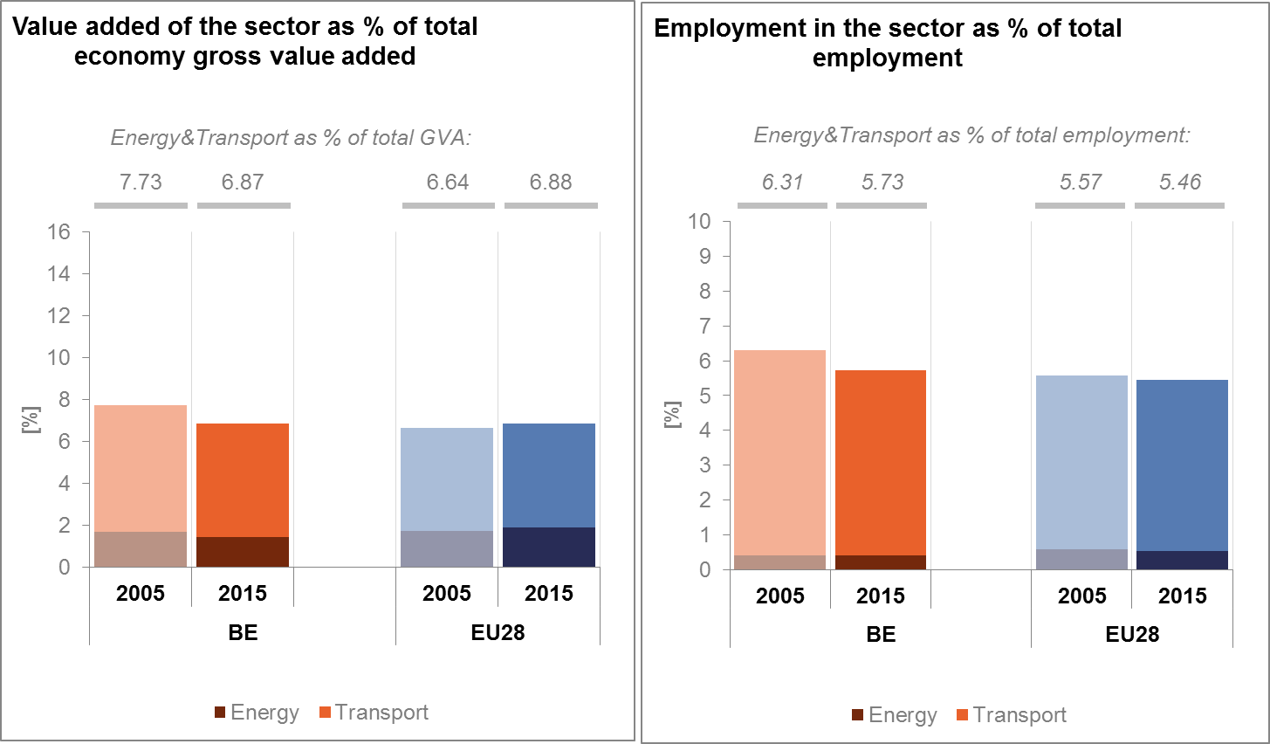

*(source: Eurostat)*

The decarbonisation of the energy and transport sectors will require significant investments and economic activity beyond the remit of these sectors themselves. The energy transition implies a structural shift in economic activity. Energy-related investment and jobs will in part migrate from traditional fossil fuel based activities towards construction, equipment manufacturing and other services related to the deployment of low carbon and clean energy technologies. At the moment, the efforts related to the low-carbon and clean energy transition in sectors beyond energy can only be partially quantified and are therefore not included in this analysis.

In the case of renewable energy sector, both the direct as well as the indirect effects on employment are being estimated. According to EurObserv'ER, in 2015, the share of direct and indirect renewable energy related employment in total employment of the economy in Belgium was 0.5%, which is comparable to the EU average of 0.54%. The turnover of the renewable energy industry in the same year was estimated at around EUR 1.72 billion, the biggest part being attributed to wind, followed by biofuels and biomass industries.

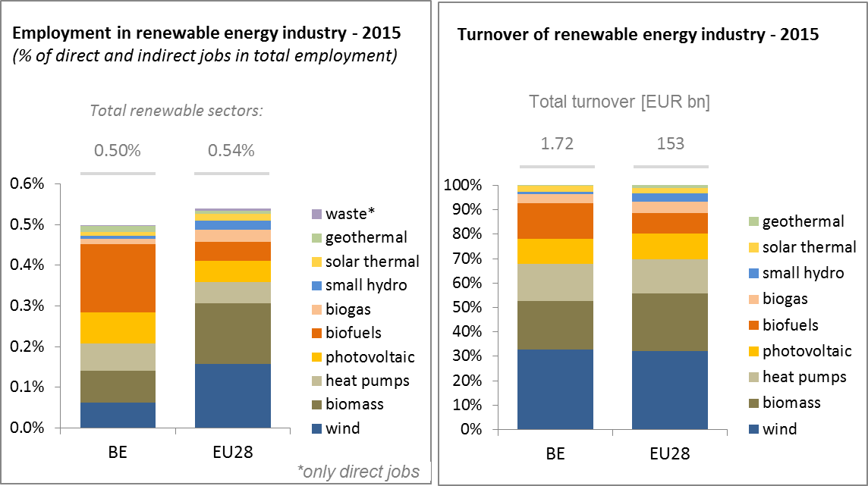

*(source: EC based on Eurobserv'Er and Eurostat)*

An indication of the level of efforts made and challenges encountered by Belgium in the energy sector is given by the gross fixed capital formation (GFCF)[4]. Investments in the electricity and gas sectors taken as reference sectors were stable at around 0.7% during 2008-2013 but dropped to around 0.5% of the country's GDP in 2015, a similar level as in the pre-crisis period.

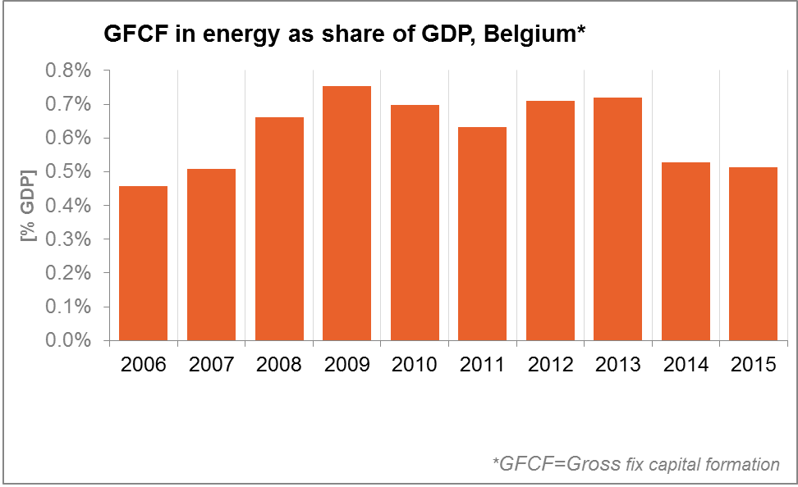

*(source: Eurostat)*

In terms of trade, Belgium is a net importer of fossil fuels and electricity. The trade deficit in energy products has fallen from about 4.3% of GDP in 2005 to 2.7% in 2015. The largest decrease is accounted for by petroleum products, but the trade deficit for gas has also fallen from 1.5% of GDP in 2005 to 1.0% of GDP in 2015, under the influence of lower energy prices.

*(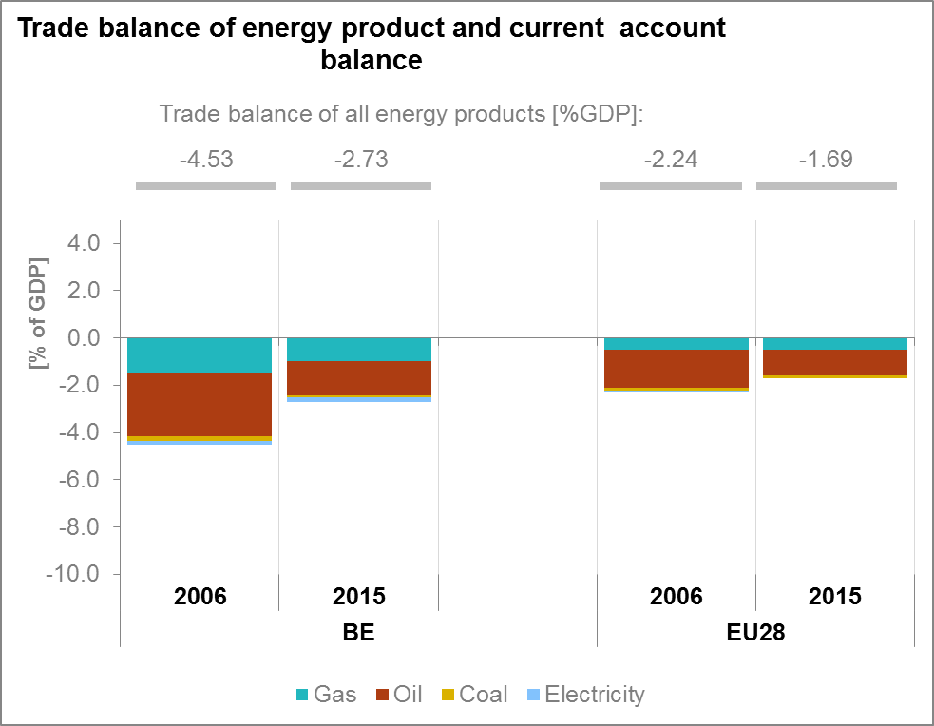*

*(source: Eurostat)*

1. **Energy security, solidarity and trust**
   1. **Energy mix**

The energy mix of Belgium differs from the one of the EU-28, as Belgium's energy mix is characterised by a lower share of coal and other solid fuels, a lower share of renewable energy and a higher share of petroleum products and nuclear. Compared to 1995, the share of renewables in Belgium increased more than EU average (from less than 1% to 6.9% of the energy mix), but remains at rather low levels, while the share of natural gas increased by 6 percentage points. The main decrease concerns the use of solid fuels (11 percentage points).

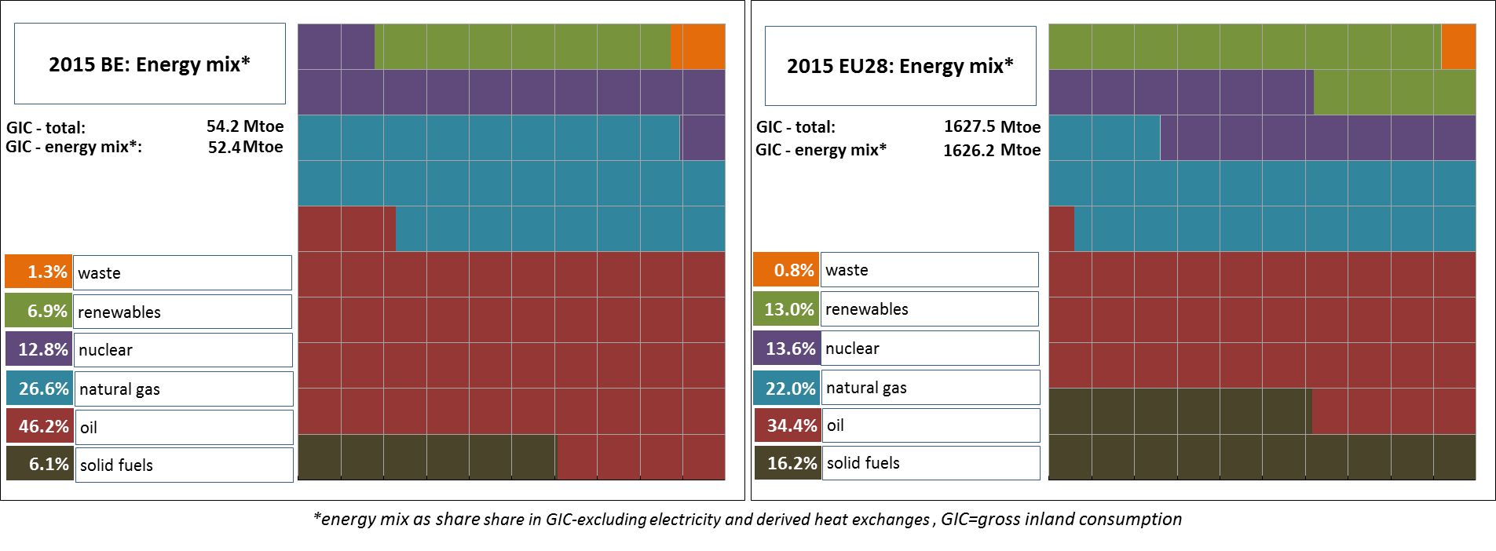

*(source: Eurostat)*

* 1. **Import dependency and security of supply**

Belgium' import dependency remains above the EU average for all fuels, and in particular for gas and petroleum products. Belgium imports all of its natural gas, with Norway as its largest non-EU supplier. A part of the imports concern transit as gas transfers represent more than four times the Belgian domestic use. Overall, the country supplier concentration index is relatively high for Belgium.

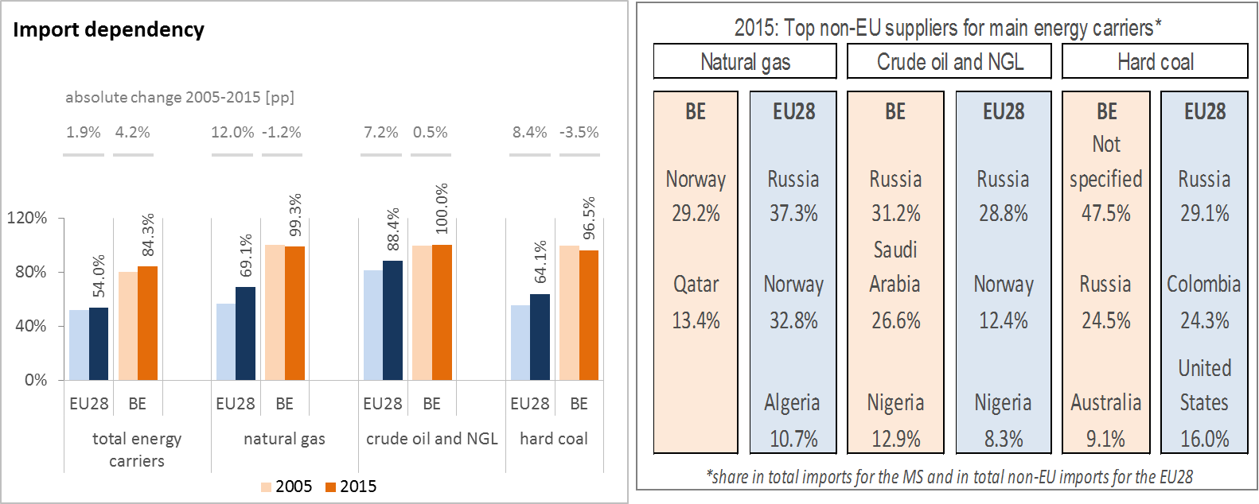

*(source: Eurostat)*

Imports of uranium and nuclear fuels are not included in Eurostat's energy balances and therefore import dependency cannot be calculated in the same way as for the main fossil fuels. Hence, complementary information is provided on imports of uranium and nuclear fuels.Provision of conversion services is ensured by EU (40%), Russia (28%), and North America (32%). The Provision of enrichment services is ensured by EU (60%] and Non –EU countries (40 %).

The security of gas supply Regulation requires that, if the single largest gas infrastructure fails in one Member State, the capacity of the remaining infrastructure is able to satisfy total gas demand during a day of exceptionally high gas demand. Belgium complies with this rule thanks to various options for gas import sources.

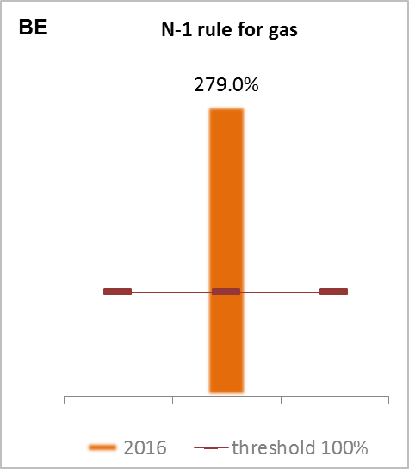

*(source: gas coordination group)*

1. **Internal market**
   1. **Interconnections and wholesale market functioning**
      1. **Electricity**

|  |  |
| --- | --- |
|  | |
| *(source: EC based on ENTSO-E scenario outlook and adequacy forecast 2014)* | *(sources: EC services based on Eurostat for the left graph and based on Platts and European power exchanges for the right graph)* |

The interconnection level[5] for electricity based on the import capacity was 19% in 2017. Various projects, notably Projects of Common Interest, are under preparation to develop electricity interconnections between Belgium and its neighbours.

The Nemo project involves the construction of a 1,000 MW direct current submarine cable between Richborough in the UK to the "Gezelle" substation in Belgium. For Belgium, this means that energy can be exchanged directly with the UK, which should lead to greater security of supply in view of the diversification engendered by a new interconnection. The final investment decision was taken in spring 2015. Construction started in September 2016, thus making it technically possible to deliver the new connection by the end of 2018. The PCI ALEGrO (Aachen Liege Electric Grid Overlay), is a DC cable with a capacity of about 1,000 MW between Belgium and Germany. The new interconnection, the first one between Belgium and Germany, can result in price convergence within the CWE region. Moreover, ALEGrO can play an important role in facilitating the integration of an increasing number of renewable energy sources. The permit granting process is ongoing and the project is expected to be commissioned in 2020. In addition, two projects of common interests (internal lines) aim at strengthening the northern Belgian border connections to allow for better integration of the electricity from offshore wind in the area as well as ensuring electricity supply around the Antwerp area in light of increasing industrial demand[6].

The level of market concentration for power generation significantly decreased over the recent years, and is now below EU average. Wholesale electricity prices are now below EU average, and decreasing. As far as electricity is concerned, the average price in Belgium has been following the average price in the neighbouring countries since 2013.

* + 1. **Gas**

Belgium occupies a strategic position in the European gas grids and serves as an important transit country, attracting international trade as a collection of connection points of several pipelines and has an important LNG terminal (in Zeebrugge), which contributes significantly to the security of supply in North-West Europe. Belgium is well interconnected with its neighbours. As a consequence, market concentration on wholesale gas markets is low in Belgium.

The average wholesale gas price in Belgium remains constant at approximately 14 EUR/MWh above the average of the neighbouring countries. Overall, it is slightly lower than the EU average.

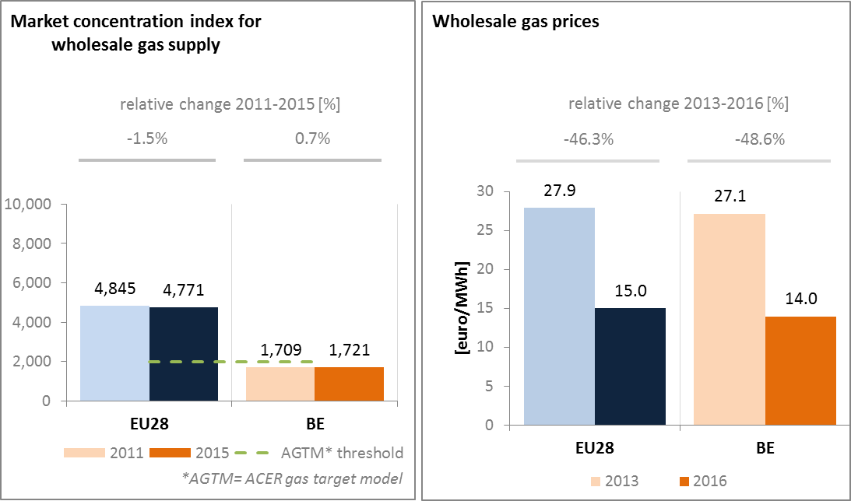

*(source: ACER for the left graph and EC services based on on Platts, gas hubs, Eurostat for the right graph)*

In the gas sector, Belgium has no PCIs. Its projects in the gas sector mainly concern conversion of the whole gas system to H-gas; the expansion of the Zeebrugge LNG terminal and the construction of a transmission line to the new LNG terminal in Dunkirk.

* 1. **Retail electricity and gas markets**

Retail markets for gas and electricity have become significantly more dynamic in recent years, as reflected in lower market shares, higher switching rates and higher entry rates. This was triggered by several government measures such as: a modification of the energy law making it easier to switch provider; a campaign organised together with local communes informing and assisting consumers in using comparison tools for comparing energy prices; and promotion of joint energy purchases. Current regulatory guidance specifies that contract termination can take place at any moment without cancelation fees (as long as the one month notification period is respected).

* + 1. **Electricity**

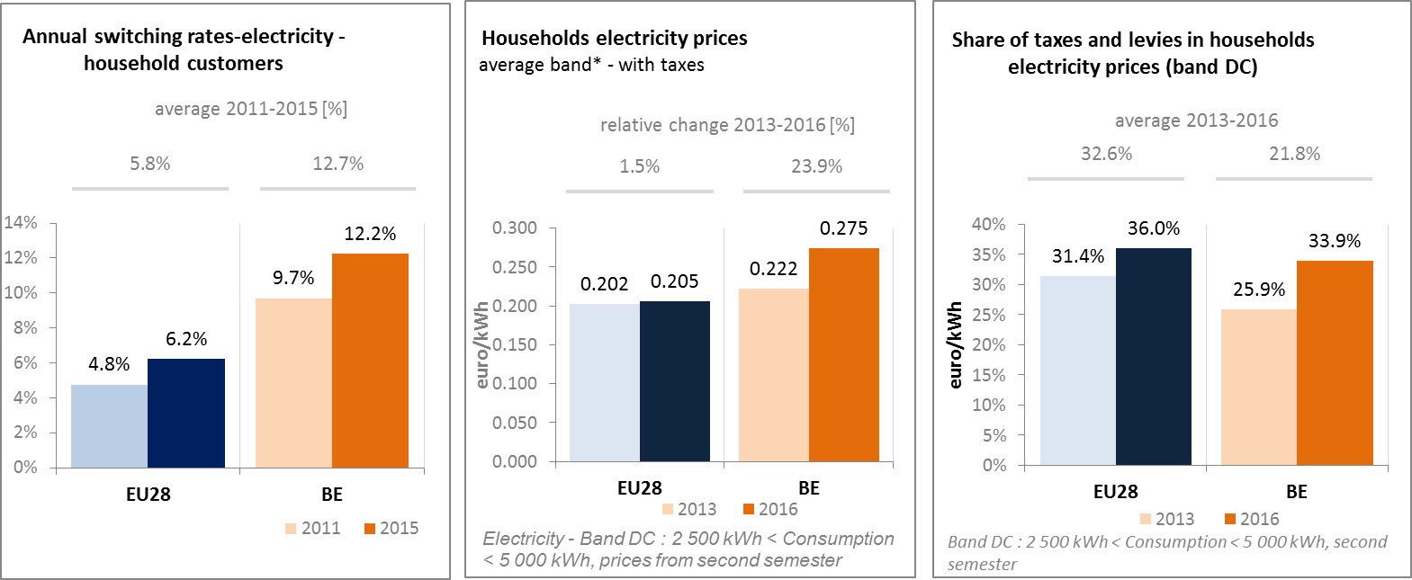

*(source: ACER) (source: Eurostat) (source: Eurostat)*

Annual switching rates were at 12.2% in 2015, well above EU average, and at a higher level compared to 2011. That means that consumers in Belgium are well-aware of their rights. The very high switching rate of consumers tends to reduce the market share of incumbent suppliers.

Domestic retail prices for electricity are above the EU average. This is notably due to consecutive increases in the non-energy component (mostly distribution and transport tariffs, as well as VAT). The reduction in the VAT rate on household electricity consumption from 21 % to 6 % introduced in April 2014 was reversed in September 2015. Intercommunales, which include utility suppliers, are subject to corporate income taxes since 2015 and have increased distribution charges as a result. In Flanders, owners of green energy installations have been required to pay a fixed surcharge for use of the distribution network since 2015. Finally, in 2016 Flanders increased a general energy contribution and abolished the free electricity all households were receiving.

Given the outcome of the cost-benefit analysis, not all the Belgian regions have so far decided to proceed with the wide-scale roll-out of smart meters in the electricity and gas markets. The Flemish did however and decided to proceed with a wide-scale roll-out of smart meters in the electricity and gas markets after a positive outcome of the cost-benefit analysis. This roll-out will start in 2019. The other Belgian regions (Walloon and Brussels-capital region) have so far not started to proceed with the wide-scale roll-out of smart meters. Nevertheless, at political level, the Walloon Region decided to encourage the roll-out of smart meters for which a legal framework should soon be established.

* + 1. **Gas**

Retail market for gas has become more dynamic in recent years, as reflected in lower market shares, higher switching rates, higher entry rates and lower household gas prices. This was triggered by several government measures to enhance price-consciousness and make it easier to switch provider which have stimulated competition on the market. Domestic gas prices are lower than EU-28 average. The share of taxes and levies in household gas price is at 23 % which is lower than for the EU28 as a whole.

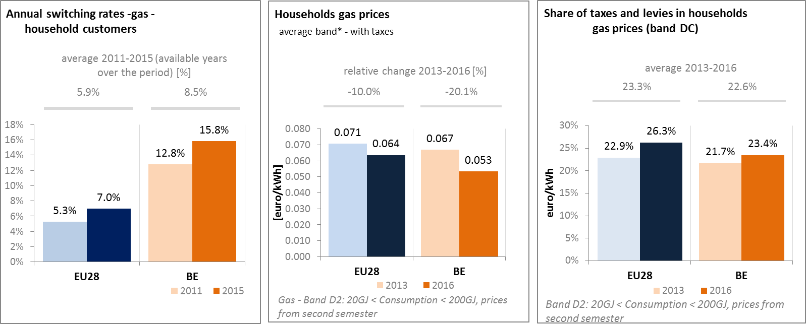

*(source: ACER) (source: Eurostat) (source: Eurostat)*

* + 1. **Market performance indicators**

According to the periodical survey of the European Commission, Belgian consumers of electricity and of gas are satisfied in line with EU average. On the period of reference (2015 compared to 2010), a slight increase in satisfaction, notably for gas markets, was visible.

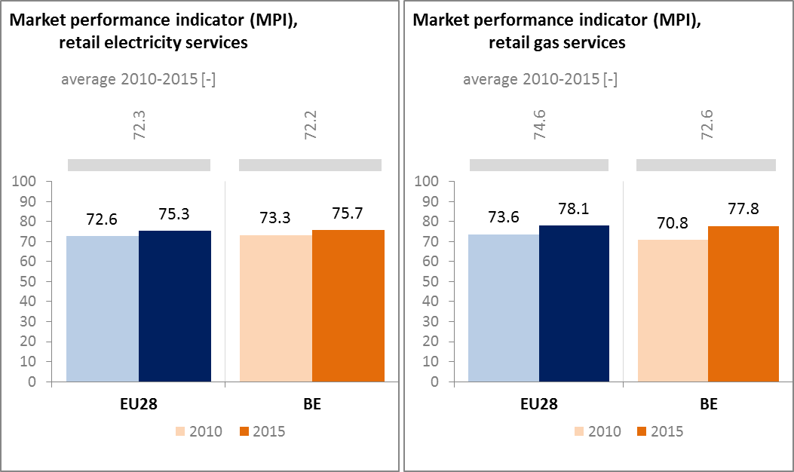

*(source: DG JUST survey)*

* 1. **Energy affordability**

Electricity prices contributed significantly to the acceleration of inflation in 2015-2016. Indeed, electricity alone was responsible for 0.3 pp. and as much as 0.7 pp. of total inflation in 2015 and 2016. Although energy price increases are subject to the ‘safety net mechanism’, the impact of this price control mechanism is limited, especially on electricity prices. This is because almost two thirds of contracts are fixed-price contracts to which the mechanism does not apply. Moreover, non-energy components account for a large and increasing percentage of the retail energy prices. Around 75% of consumer electricity prices are network charges (distribution and transmission costs), levies, taxes and VAT, which are not subject to the price control mechanism.

The energy poverty problem is less acute than in other Member States. However, it has received increased visibility over the last years due to the action of vocal civic organisations and to rising energy prices. Between 2005 and 2014 the share of expenditure of lowest income households on energy increased from 6.6% to 7.8% in Belgium, in comparison to the EU average change from 7.1% to 8.6%. In 2015, 14.8% of the lowest-income population reported to be unable to keep home adequately warm, in comparison to the EU average of 22.7%. Important progress was made since 2005 where this rate was 29%.

Energy poverty in Belgium is mainly approached by several measures. First consumers are provided with protection of access to energy, through disconnection safeguards. In addition Belgium applies a system of social tariffs which is intended to refer to market prices in order to limit the impact of the public's intervention on electricity market.

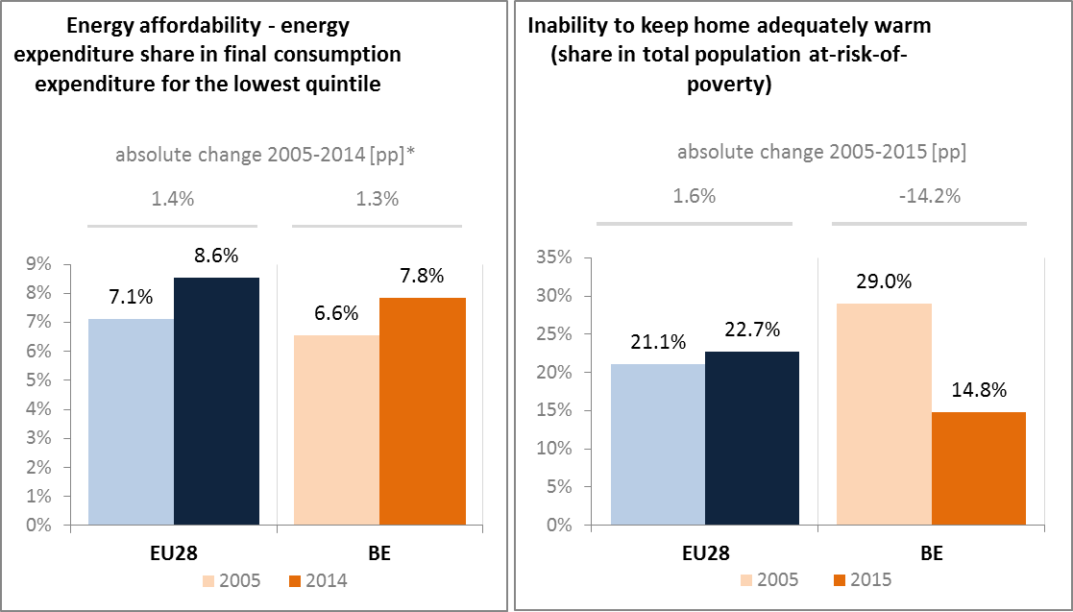

*(source: ad-hoc data collection of DG ENER based on HBS with the support of Eurostat and national statistics)*

1. **Energy efficiency and moderation of demand**

In 2015, Belgium's primary energy consumption was 45.7 Mtoe. Final energy consumption was 35.8 Mtoe. This is an increase compared to 2014, which could be explained because of a colder winter, increasing the demand for heating. Hence, there is still a gap between Belgium's primary and final energy consumption and its indicative national 2020 targets (43.7 Mtoe in primary consumption and 32.5 Mtoe in final energy consumption**)**. Therefore, there is still the need to reduce at higher rate energy consumption in 2016-2020 compared to 2005-2015 in order to reach the energy efficiency target.

Belgium has made some progress in developing relevant energy efficiency policies. In 2015, the country is on track to achieve savings obligations under Article 7 (efficiency obligation schemes) of the Energy Efficiency Directive. However, more needs to be done.

In this context, the work that has started (end of January 2017) on the "Energy Pact" constitutes an opportunity for the federal and regional energy ministers to build the energy transition and vision for the longer term. It should result in a set of concrete policy measures, based on a clearly-defined policy path, ensuring the combination of four energy visions (of the 3 regions and the federal level) and their compatibility. In addition, the intention is that the Energy Pact will consult all stakeholders to come to a widely supported agreement. This process will also feed the Belgian integrated energy and climate plan which is required under the proposal for the Regulation on Governance.

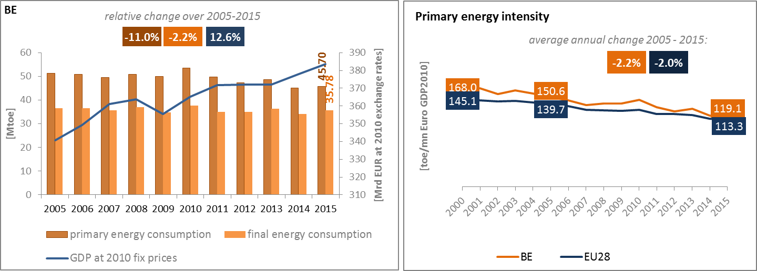

*(source: Eurostat)*

Overall primary energy intensity has decreased in line with EU average over the last ten years, and remains slightly above EU average. Regarding the split of final energy consumption per sector, Belgium shows a higher consumption in industry than for the EU as a whole. Conversely, consumptions by the other sectors are below EU average. This shows again the key role played by energy-intensive industries in Belgium's economy.

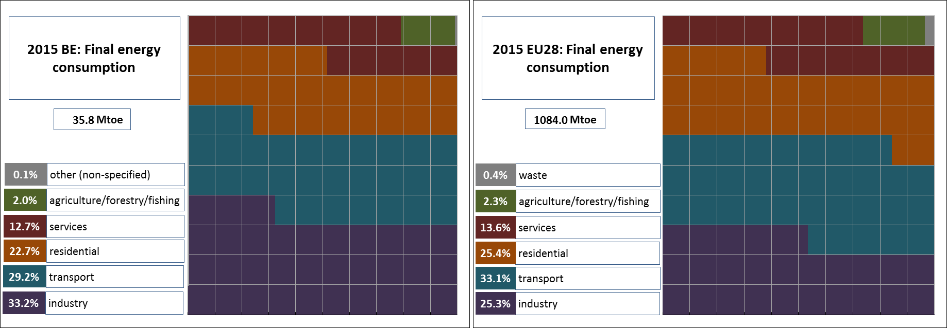

*(source: Eurostat)*

In terms of energy efficiency, some progress can be observed in the final energy intensity in industry services, as well as in the final consumption per m2 for the residential sector.

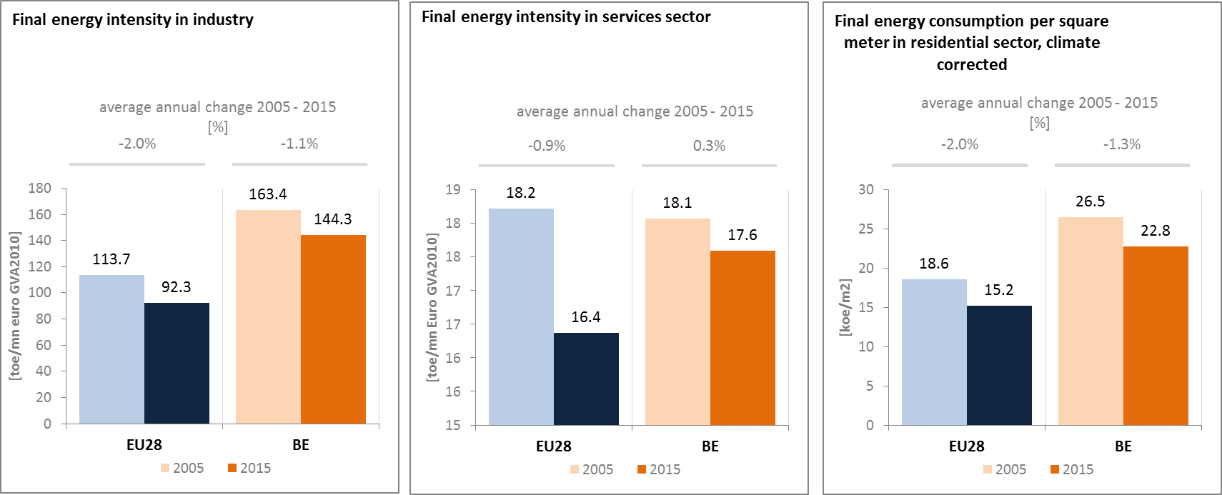

*(source: Eurostat) (source: Eurostat) (source: Odyssee database)*

Over the period 2005-2015, the final energy consumption in transport increased at an annual average rate of 0.5%, while GDP increased by 1.2% per annum on average. Passengers transport activity increased in 2015 by 3.1% as comparing to 2005, similar with freight transport activity and with the increase of energy consumption in transport (excl. aviation). In addition, the share of collective passengers land transport has slightly decreased, indicating a relative higher use of private transport.

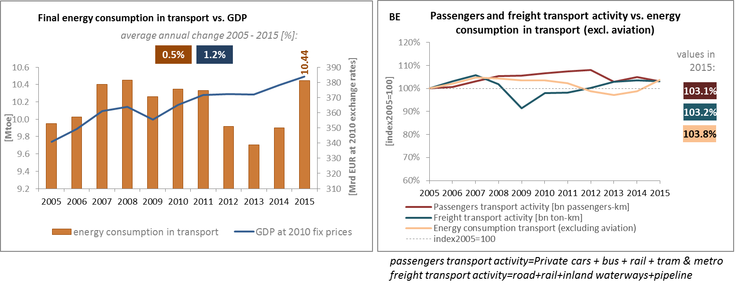*(source: Eurostat) (source: Eurostat and DG MOVE pocketbook)*

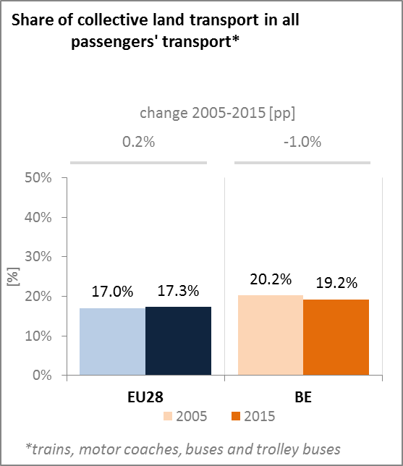

*(source: Eurostat)*

The management and development of the road network, the waterway network and local and regional public transport are a regional competence. In 2016, the Walloon Region started to implement its Plan Infrastructure, which is focusing on the upgrade of the road and waterway network. The Brussels-Capital Region will mainly invest in public transport and cycling routes in the following years. More specifically, for the Flemish road network, the Government is preparing the capacity increase of the ring roads of Brussels and Antwerp, but elsewhere they are also tackling bottlenecks and missing links. Moreover, in April 2016 all three regions implemented road pricing for road haulage.

Belgium is facing a growing problem of peak-hour traffic congestion, which undermines the country’s attractiveness for foreign investors and has major economic and environmental costs. Public transport has been identified as instrumental for a modal shift in passenger transport. In Brussels, the modernisation and expansion of the metro and tram networks is ongoing and 8,000 park & ride spaces will be added in the years to come. To the north of the city, Flanders is preparing the construction of a regional light rail network (Brabantnet).

The waterway network has also an important role in the modal shift from road haulage and the reduction of congestion. In 2017, works will start on the Seine-Scheldt link in two regions. Besides this, works are ongoing throughout the country on the old canals and on several sea and inland locks.

Contrary to local and regional public transport, the railway network is a federal competence. Currently negotiations are ongoing about a new, multiannual investment plan. The plan is aimed at investments for the next five years, where priority will be given to the completion of the Regional ExpressNet (GEN/RER) around Brussels.

1. **Decarbonisation of economy**
   1. **GHG emissions**

The Effort Sharing Directive target for Belgium is to reduce greenhouse gas emissions in non-ETS sectors by 15% relative to 2005 levels. According to the latest (2017) national projections based on existing measures, the 2020 target is expected to be missed, with non-ETS emissions only 11.5% lower than 2005 levels in 2020. While Belgium would therefore miss the 2020 target itself, it expects to generate a small surplus based on emission levels over the whole compliance period 2013 to 2020.

The use of inter-temporal flexibilities (banking of allowances during the first part of 2013-2020 – resulting in part from the economic and financial crisis – compensating for excess emissions in the latter part of the period) would therefore allow Belgium to comply with the ESD rules.

The various entities of Belgium develop policies and measures. However, an internal effort sharing agreement between federal and regional authorities has now been reached. In accordance with this so-called Cooperation Agreement on the national burden-sharing 2013-2020, the federal government is committed to pursue existing policies and measures allowing a total reduction of emissions of 15.250 kt CO2-equivalent for 2013-2020 and to implement new policies and measures resulting in an additional reduction of at least 7.000 kt CO2-eq for the period 2016-2020. On 25 January 2017 a national debate on the introduction of "carbon pricing" in non-ETS sectors was launched. Regarding the ETS sector, the accumulated revenues from the auctioning of emission allowances under the ETS (according to Belgium's own reporting amounting to around EUR 354 million in 2015) will now be distributed among the Federal State and the regions and used for climate and energy purposes.

Belgium’s non-ETS emissions are mainly caused by direct fuel consumption, predominantly for residential and commercial purposes. The renovation of the inefficient building stock remains a key sectorial challenge. In turn, the continued favourable treatment of company cars contributes to pollution, congestion and greenhouse gas emissions.

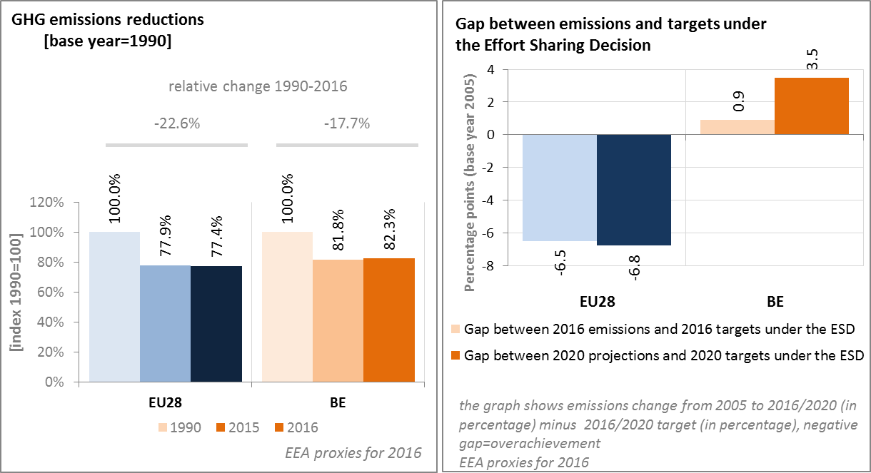

*(source: EC and EEA)*

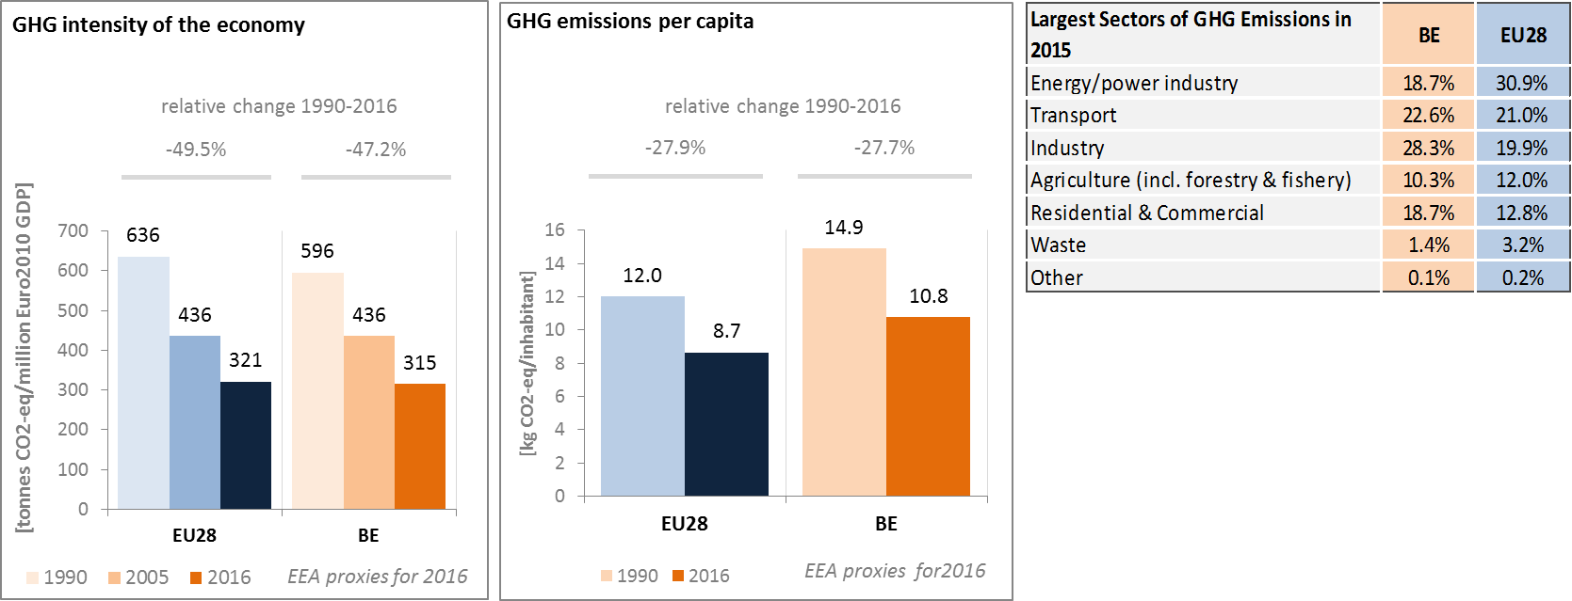

*(source: EC and EEA)*

Preliminary accounts under the Kyoto Protocol for Belgium show overall removals of -0.3 Mt CO2-eq. as an annual average in the period 2013-2015. For comparison, the annual average of the EU-28 accounted for removals of -119.0 Mt CO2-eq. It should be noted that in this preliminary simulated accounting exercise, removals from Forest Management did by far not exceed the accounting cap.

Emissions by Deforestation clearly exceed removals by Afforestation and are also higher than removals by Forest Management. Overall, there is a slightly increasing trend in removals mainly due to increasing removals by Afforestation. This is partly compensated by very minor increases in emissions by Deforestation, while removals by Forest Management remained constant over the course of the three-year period.

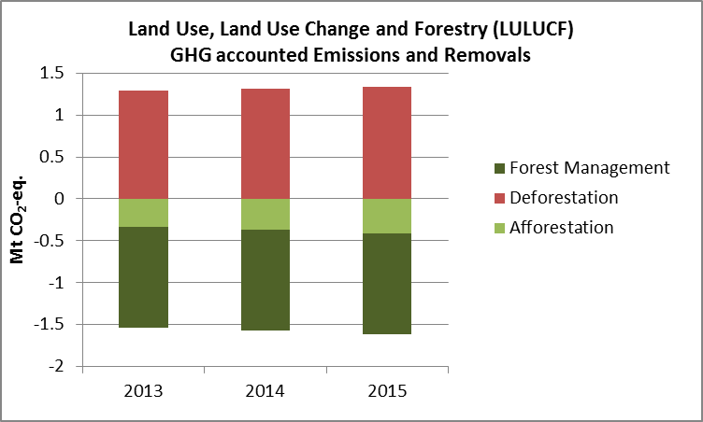

*Note: Forest Management credits are capped and presented as yearly averages when the total Forest Management credits of the considered period exceed the simulated cap over the same period.*

*(source: EC and EEA)*

**CO2 emissions in transport and alternative fuelled vehicles**

CO2 emissions from road transport are 31% higher than in 1990 in Belgium, having stabilised since 2005. Average CO2 emissions from new cars registered in Belgium have decreased by around 25% since 2005. In 2016, average CO2 emissions from new cars were 115.9 g CO2/km (EU fleet-wide target is 130 g CO2/km by 2015 and 95 CO2/km by 2021).

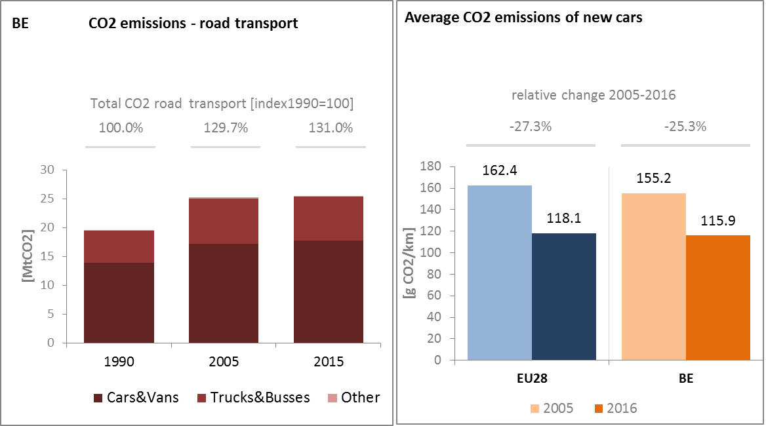

*(source: European Environment Agency)*

Over the last four years, the number of electric charging points in Belgium has increased from 378 in 2013 to 1472 units in 2016.

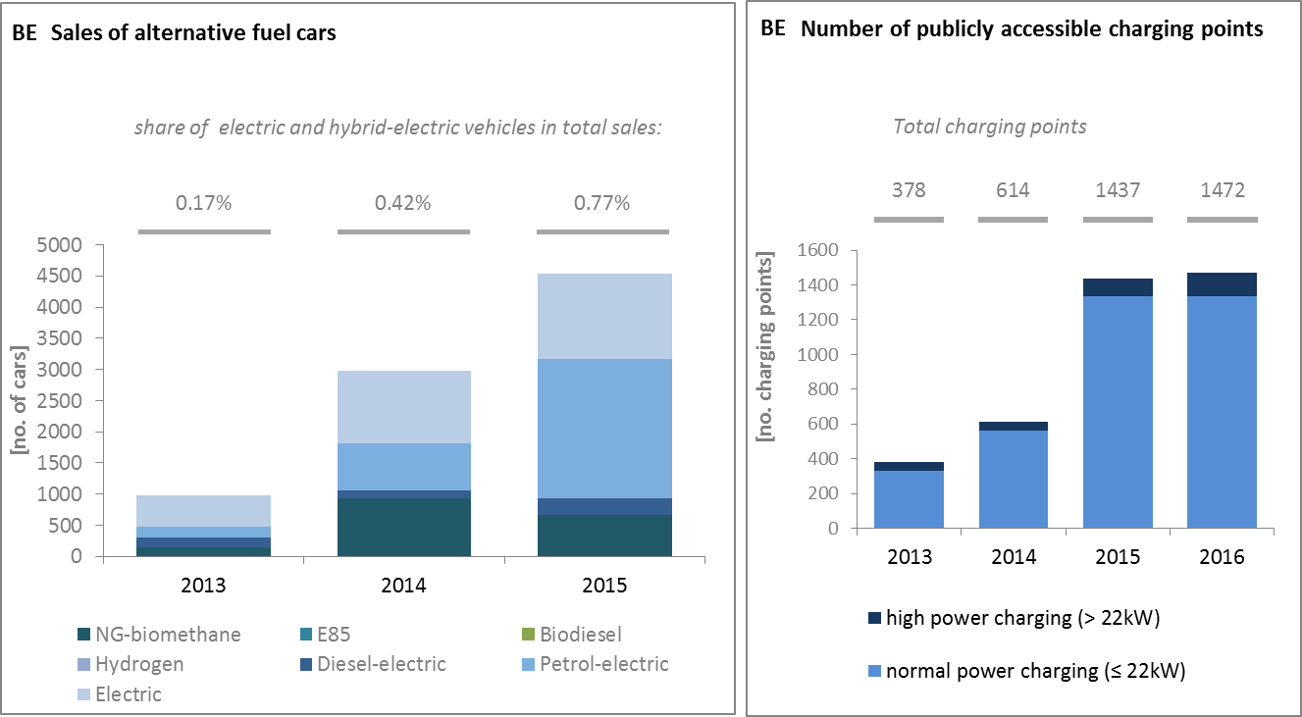

*(European Environment Agency) (European Alternative Fuels Observatory)*

National Policy Frameworks under Directive 2014/94/EU on alternative fuels infrastructure have to establish targets, objective and measures for the development of the market of alternative fuels in the transport sector and the deployment of the relevant infrastructure. Belgium has submitted its National Policy Framework as requested under article 3 of the Directive 2014/94/EU.

A detailed assessment of the Belgian National Policy Framework in terms of its compliance with the requirements of Directive 2014/94/EU on alternative fuels infrastructure, its contribution to achievement of long-term energy and climate objectives of the Union and coherence of its targets and objectives in terms of cross-border continuity has been published as part of the Communication on Alternative Fuels Action Plans (COM(2017)652) and  the related staff working document SWD(2017) 365.

* 1. **Adaptation to climate change**

Belgium adopted a National Adaptation Strategy (NAS) in 2010. It is a science-based document with a systematic and sectoral approach. A draft National Adaptation plan (2016-2020) was adopted in December 2016 and is foreseen to be finalised in 2017. Based on a comprehensive risk and vulnerabilities assessment as well as competence sharing between the different entities, Belgium has identified a number of vulnerable sectors that will need to adapt, such as agriculture, biodiversity, built environment, coastal areas, crisis management, development cooperation, energy, environment, fisheries, forests, health, infrastructures, industry & services, research, tourism, transport, water management. It has not yet developed its monitoring system and related indicators to monitor action in the vulnerable sectors.

* 1. **Taxes on energy and transport and fossil fuel subsidies**

The overall tax burden on energy and transport in Belgium amounts to 1.9% of GDP, which is over 0.4 percentage points lower than the EU average. It is particularly the tax burden on heat and electricity, and, to a lesser extent, the fuel taxation that is lower. Taxation of transport vehicles, on the other hand, is above the EU-average, despite a decrease since 2005. The tax burden on vehicles and transport fuels has also fallen since 2005. Belgium does not apply a carbon component in the taxation of fuels. The vehicle taxation includes environmental components reflecting, inter alia, CO2 emissions, with different rules across the regions.

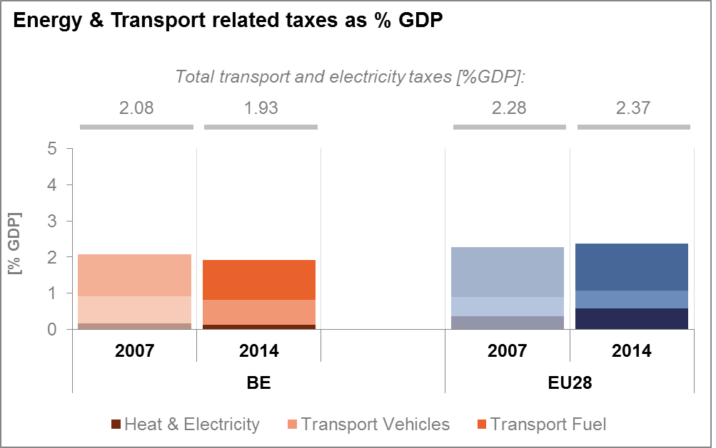

*(source: Eurostat)*

The “tax shift” adopted by the federal government in July 2015 included only two measures related to climate change mitigation: an increase of the VAT on electricity and of the excise duties on diesel. The environmental benefit of this reform is likely to be limited, as compared to the broader challenges associated with congestion, air pollution and greenhouse gas emissions from the transport sector.

**

*(source: OECD Inventory of Support Measures for Fossil Fuels 2015)*

Fossil fuel subsidies showed no decrease in Belgium in the past decade, with even some increasing trend in the last year.

* 1. **Renewable energy**

In 2015, for the first time, Belgium's renewable energy share decreased, compared with the previous year. This is notably due to decreases in RES shares in the heating and cooling and transport sectors, and also explained by the drop of biodiesel supply by 42% compared to 2014 because of the invalidation of the law specifying the rules for the mixing of biofuel in diesel in June 2015.

Although the RES share in 2015 is above the 2015-2016 indicative target, such a tendency would not be compatible with a timely target achievement. Therefore, there is a need to take adequate measure to foster developments in all sectors. Moreover some technologies, such as offshore wind, are still lagging behind and additional use of their potential could be made. Agreement has been reached on dividing responsibility for meeting the 13% target between the different regions, but attention should be paid to monitoring implementation of the sub-targets.

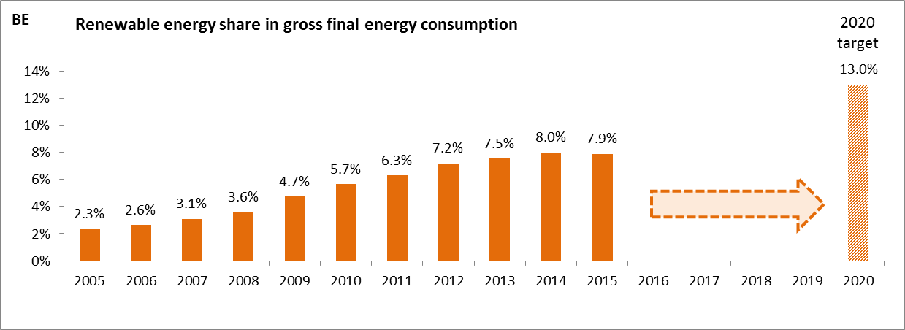

*(source: Eurostat-SHARES)*

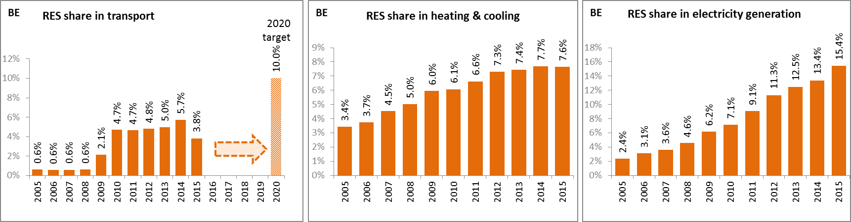

*(source: Eurostat-SHARES)*

Thanks to the deployment of renewables since 2005, it is estimated that Belgium has consumed in 2014 about 6.7% less fossil fuels than they would have otherwise. In addition, it is estimated that GHG emissions have been 6.5% lower[7]. Such results are lower than the EU average, due to slower deployment of renewable energy in Belgium than in the rest of the EU.

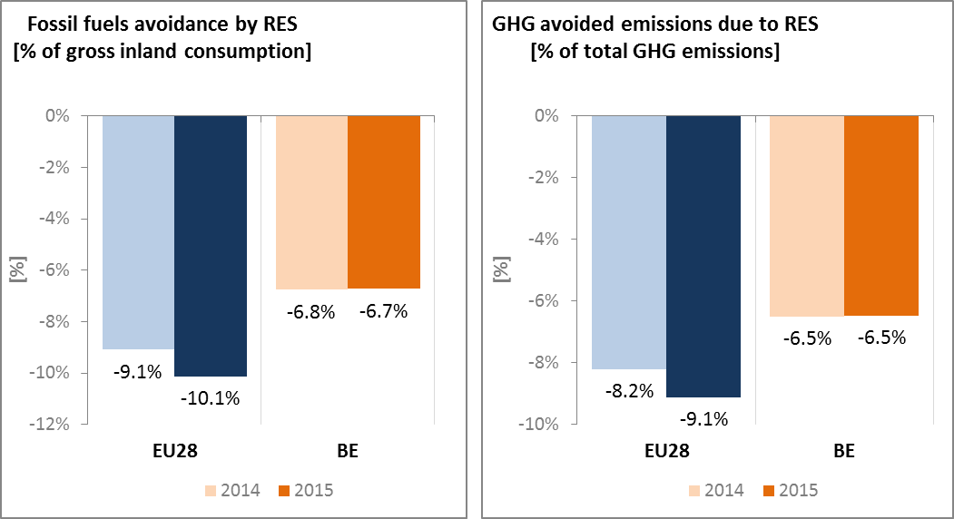

*Source: EEA Report No 3/2017*

* 1. **Contribution of the Energy Union to better air quality**

Air quality in Belgium continues to give rise to human health concerns. For the year 2013, the European Environment Agency estimated that about 10,050 premature deaths were attributable to fine particulate matter (PM2.5) concentrations and 2,320 to nitrogen dioxide (NO2) concentrations[8].

For NO2, Belgium reported exceedances of the binding EU air quality standard[9]. For the year 2015, Belgium reported exceedances of the limit value for NO2 in 2 out of the 11 air quality zones in Belgium[10].

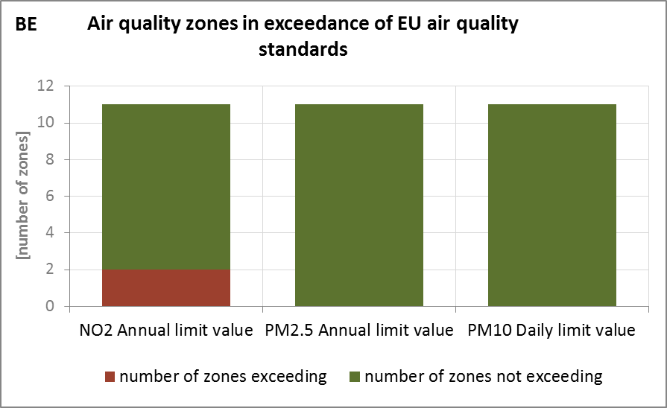

*(source: EEA)*

The health-related external costs from air pollution in Belgium have been estimated to be more than EUR 8 billion/year (income adjusted, 2010), which includes the intrinsic value of living a healthy life without premature death as well as the direct costs to the economy such as healthcare costs and lost working days due to sickness caused by air pollution[11].

The Energy Union has the potential to substantially contribute to addressing these air quality problems through measures reducing emissions of both GHG and air pollutants such as PM and nitrogen oxides (NOx) from major contributing sectors such as (road) transport, energy production, industry and residential heating (e.g. stoves and boilers) as shown below[12].

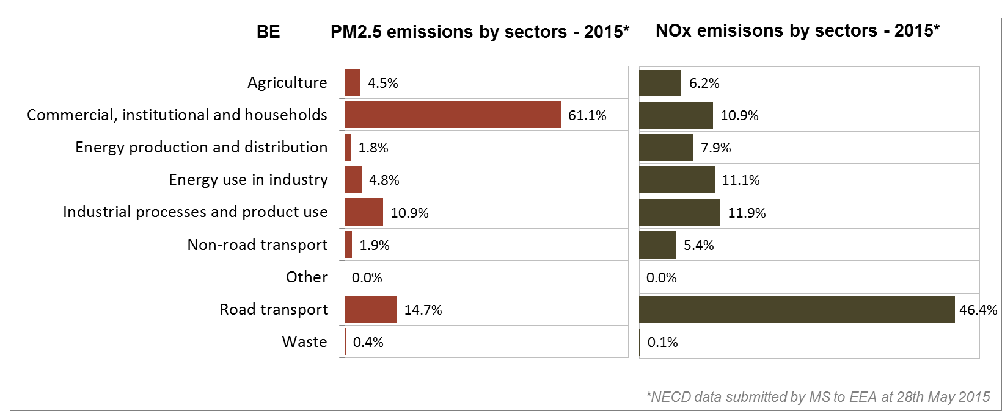

*(Source: EEA. This table reflects only sources of primary PM2,5 emissions.)*

1. **Research, innovation and competitiveness** 
   1. **Research and innovation policy**

An 'energy transition fund' is active in Belgium at the federal level to finance innovative energy research, development and demonstration (RD&D) projects such as for renewable energy generation in marine areas or biofuel production from algae. Other areas identified for funding are nuclear (fusion, fission, and nuclear waste management), energy storage, demand-side management, and smart transport networks. In recent years, public funding to support energy R&I has increased mainly at the regional level, particularly in renewables and energy efficiency.

In the Flemish Region, energy research is mainly financed via two funding agencies, the Agency for Innovation by Science and Technology (IWT) and the Research Foundation Flanders (FWO). In Wallonia, energy-related RD&D focuses on: efficient fossil fuel combustion, including combined heat and electricity production; biomass, wind energy, solar energy and fuel cells; hybrid energy systems to integrate new and renewable energy sources into traditional energy systems; technologies to improve the efficiency of final energy use; and new energy storage technologies.

Finally, in the Brussels-Capital region, Innoviris funds energy-related research under the following schemes: ANTICIPATE (e.g., developing new knowledge about the complex urban environment of Brussels), BRIDGE (funding strategic platforms with applications for relevant economic sectors in Brussles) and CO-CREATE (funding projects in applied research and innovation that work within an interactive co-creation dynamic), as well as under the bottom-up industrial research schemes and the European P2P schemes in which Innoviris participates.

Belgium is an active contributor to the ongoing work of the Strategic Energy Technology (SET) Plan. It participates in all temporary working groups for the implementation of the integrated SET Plan, co-leading the one dedicated to nuclear safety.

Regarding the Horizon 2020 programme, Belgium has received so far 5.1% of the EU contribution devoted to the 'secure, clean and efficient energy' part of the programme. As of September 2017, 233 participants from Belgian organisations have been awarded EUR 92 million in Horizon 2020 energy projects. This includes a grant of EUR 8.3 million to GeoSea for its participation in project DEMOTIDE (ocean tidal arrays), and a grant of EUR 6.6 million to ArcelorMittal Belgium for its participation in project STEELANOL (bio-ethanol from steel industry exhaust gases).

* 1. **Investments and patents in the Energy Union R&I priorities**

In 2015, public (national) investments in the Energy Union R&I priorities reached EUR 162 million having decreased by 3% compared to 2014. The highest share of investments (48%) was attracted by the Nuclear Safety priority, followed by the Efficient Systems and Smart System (21% and 12% respectively). In the period 2007-2015, the maximum public investment was EUR 211 million, reported in 2012. In 2014, the most recent year for which data from most Member States are available, public investment per GDP in Belgium was higher than the EU average.

Private investment in the Energy Union R&I priorities in 2013 was estimated at EUR 159 million (1% of the private R&I investment in Energy Union R&I priorities in the EU). The focus was on Efficient Systems, which received 39% of these investments, followed by Renewables with a share of 27%.

In 2013, the most recent year for which complete patent[13] statistics are available, 57 companies and research organisations based in Belgium filed 84 patents in low-carbon energy technologies (1% of the EU total). The focus was on Efficient Systems and Renewables (32% each), and Smart System (21%).

In 2013, private R&I investments and patents in Energy Union R&I priorities were lower than the EU average when normalised by GDP and by population respectively. In the period 2007-2013, private R&I investments decreased by 3% per year on average, contrary to the EU indicator that increased by 6%. For the same period, the number of patents displayed an average rate of increase of 14%, which was lower than the EU average (15%) for the same period.

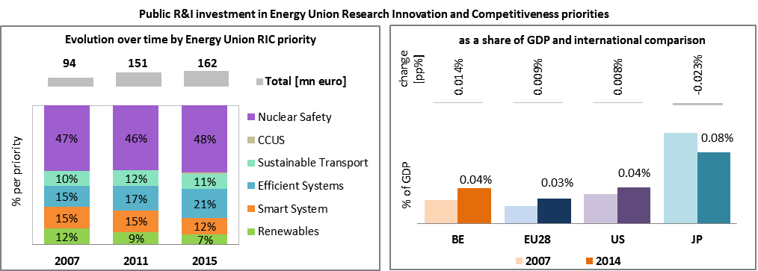

*Note: The international comparison (right) is shown for 2014 (Belgium had reported EUR 169 million). Reporting at EU level for 2015 is not as complete, and very few countries have reported for 2016.*

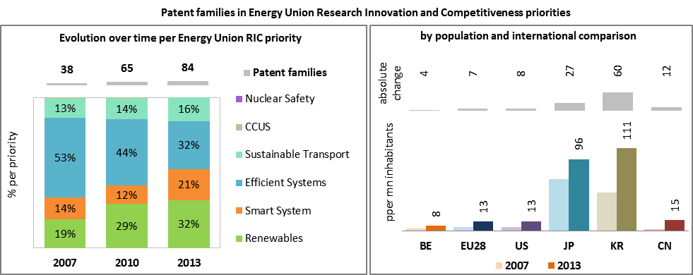

*(Data sources: Public investment as available in the International Energy Agency RD&D Statistics database[14] for codes relevant to Energy Union RIC priorities. Patent data based on the European Patent Office PATSTAT database[15]. Private investment as estimated by JRC SETIS. Detailed methodology available from the JRC[16].)*

* 1. **Competitiveness**

The real unit energy costs (RUEC) that is the amount of money spent on energy sources needed to obtain one unit of value added, has increased in the Belgian manufacturing industry since 2005. It has also remained much higher in Belgium than in the EU28 or in the US. One explaining factor is the relatively high energy intensity of the manufacturing sector.

Regarding energy prices paid by industrial customers, electricity prices are slightly above EU average, as well as above OECD average. Regarding gas, prices lower than on average in the EU and on-par with OECD average.

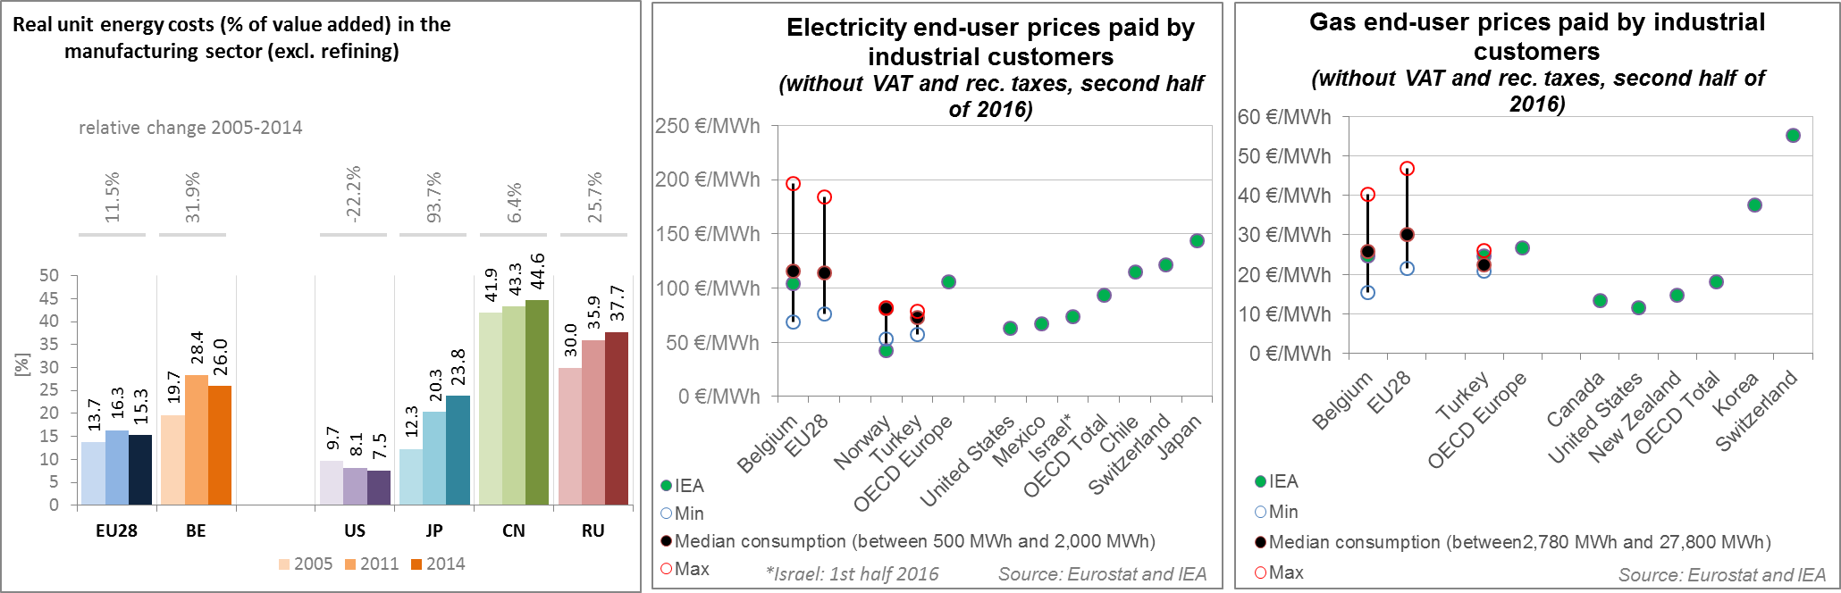

*(source: ECFIN) (source: Eurostat and IEA)*

Regarding the competitiveness in renewable energy, Belgium is overall neither specialised in wind nor solar energy, although it has a revealed comparative advantage[17] in key parts of wind turbines such as generating sets and gearboxes. Its comparative advantage in wind energy technologies has decreased since 2005. The relative trade balance[18] shows that Belgium is a net exporter of wind components and a net importer of solar energy, at comparable levels as the EU28 average.

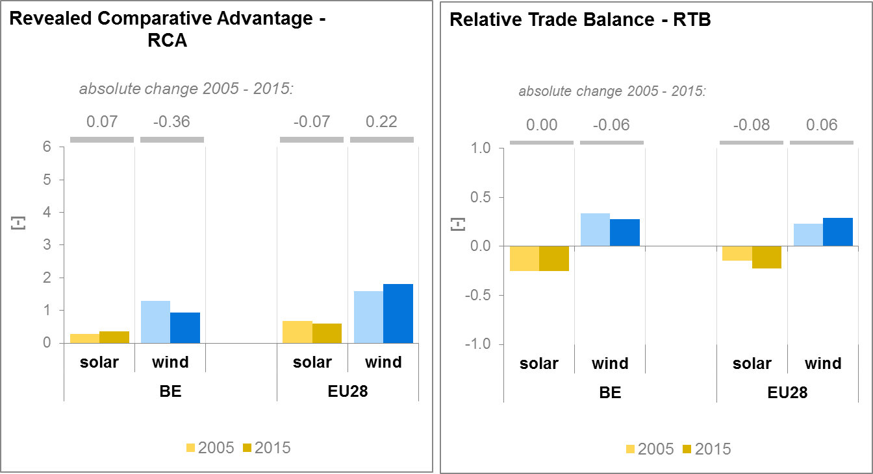

*(source: UN comtrade)*

1. **Regional and local cooperation**

Belgium is a member of three Regional Groups which have been established under the Ten-E regulation: Northern Seas Offshore Grid, North South Electricity Interconnections in Western Europe and North South Gas Interconnections in Western Europe.

Benelux-cooperation (Belgium, The Netherlands and Luxembourg) in the field of energy mainly takes place through the Pentalateral Energy forum, the Gas Platform and the North Seas Energy Forum.

The Pentalateral Energy Forum (PLEF) is the framework for regional cooperation in Central Western Europe (BENELUX-DE-FR-AT-CH) towards improved electricity market integration and security of supply. The Ministers for Energy of PLEF countries meet regularly in order to discuss energy policy matters and give guidance to this regional cooperation. The initiative aims to give political backing to a process of regional integration towards a European energy market. This cooperation is formalized trough the Memorandum of Understanding of the PLEF, signed on the 6th of June 2007 in Luxembourg.

The added value of this regional cooperation between Ministries, Transmission System Operators (TSOs), the European Commission, Regulatory authorities and the Market Parties Platform lies in its ability to move faster, to reach more specific recommendations and to act as a development centre for new ideas. In 2013, ministers renewed the mandate, putting more emphasis on a regional approach to security of supply and short term market integration. In the Political Declaration of the PLEF of 7 June 2014, the Ministers of Energy requested a Pentalateral Generation Adequacy Assessment. On 26 June 2017 the Parties signed a ‘Memorandum of Understanding of the Pentalateral Energy Forum on emergency planning and crisis management for the power sector’ in the framework of the Risk Preparedness provisions of the Clean Energy Package for Europeans.

Belgium is also a member of the Gas Platform (Benelux, Germany and France) where further market integration and the Regulation regarding security of supply and the coordinating of the emergency response plans are discussed.

Belgium was one of the drivers behind the North Seas Countries Offshore Grid Initiative (NSCOGI), which was established in 2010 as an intergovernmental initiative. It aims to fully develop the North Sea's renewable energy potential and to promote the strategic, coordinated and cost-effective development of the offshore and onshore electricity grid.

Belgium has much to gain from a regional approach in the offshore field: reduced industrial electricity prices (better interconnection, optimisation of offshore wind), a regional market for the offshore shipping industry, electricity trading opportunities, maintaining access to the North Sea for other industries (e.g. fishing) and uses (e.g. military) that could be crowded out by unrestricted wind-farm development.

European Territorial Cooperation – 'Interreg' – under EU cohesion policy provides further opportunities for cross-border, transnational and interregional cooperation, including in the Energy Union areas.

Cities and urban areas have a key role in the energy and climate challenge. The Urban Agenda for the EU, established by the Pact of Amsterdam in May 2016, better involves cities in the design and implementation of policies, including those related to the Energy Union. It is implemented through Partnerships, in which the Commission, Member States, cities and stakeholders work together on a number of important areas, including on Energy Transition, Urban Mobility, Air Quality, Climate Adaptation and Housing. Belgium is participating in the partnerships on Energy Transition, with the city of Roeselare as co-coordinator, and Urban Mobility, as member.

By 2016, in the context of the Covenant of Mayors, the sustainable energy action plans delivered by 176 Belgian municipalities had been assessed. Overall, these 176 municipalities cover about 5.6 million inhabitants. These municipalities committed to reducing GHG emissions by 20.4% by 2020 (as compared to 1990 baseline), a lower percentage reduction than at EU level, but leading to higher emissions per capita.

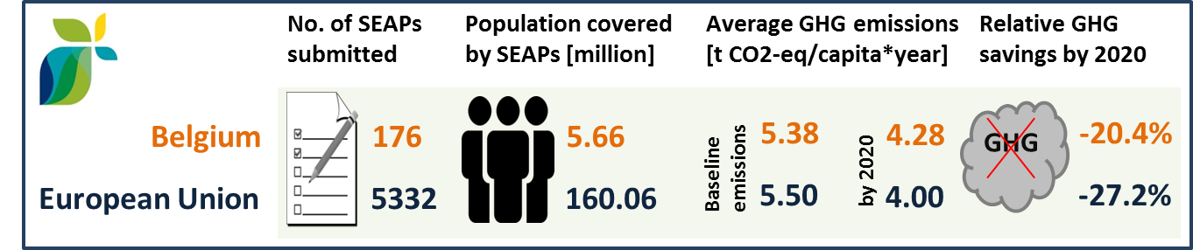

*(source: JRC 2016. Notes: SEAP=sustainable energy action plan, GHG=greenhouse gas emissions)*

In Belgium, by September 2016, 26 cities (covering 3.13 million inhabitants) have committed to conduct vulnerability and risk assessment and develop and implement adaptation plans in the framework of the Covenant of Mayors for Climate and Energy.

1. **Cohesion policy and EU clean energy investments**

EU cohesion policy makes a key contribution to delivering the Energy Union objectives on the ground, including investment possibilities to implement energy policy objectives in Belgium which are complemented by national public and private co-financing, aiming at optimal leverage. It also ensures integrated territorial solutions to energy and climate challenges, supports capacity building and provides technical assistance.

Over 2014-2020, cohesion policy is investing some EUR 125 million in energy efficiency improvements in public and residential buildings and in enterprises, as well as in high-efficiency cogeneration and district heating and in renewable energy in Belgium. Cohesion policy is also investing significantly in R&I and in SME competitiveness in Belgium, based on the regional strategies for smart specialisation. For Belgium, the strategies include a focus on sustainable energy and low-carbon economy. At this stage, at least EUR 10 million is foreseen for investments in R&I and adoption of low-carbon technologies in Belgium, but this might increase further in line with the evolving content of the smart specialisation strategy. A further estimated EUR 68 million is invested in supporting the move towards an energy-efficient, decarbonised transport sector.

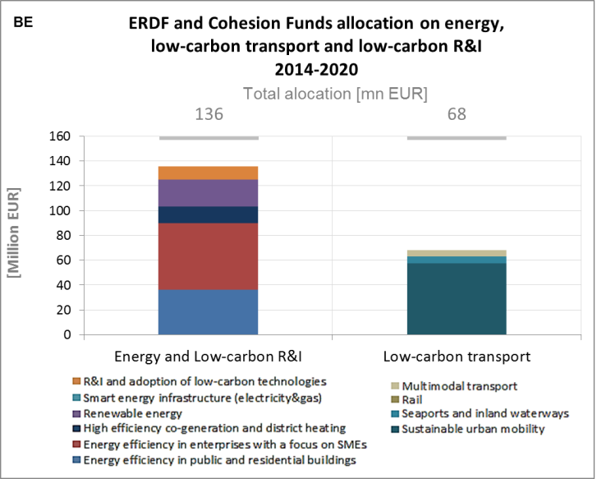

*(source: DG REGIO)*

These investments are expected to contribute to around 540 households with improved energy consumption classification, a decrease of around 420,000 kWh per year of primary energy consumption of public buildings, and around 11 MW of additional capacity of renewable energy production. Overall, the cohesion policy investments in Belgium over 2014-2020 are expected to contribute to an estimated annual decrease of GHG emissions of around 11,000 tonnes of CO2eq.

For example, an innovative project which creates jobs, the Brussels Greenbizz goals include boosting sustainable economic sectors in Brussels and supporting business initiatives in the sustainable economy by offering start-ups an optimum environment. The advantage of the project, supported by the European Regional Development Fund (ERDF) from 2010 to 2016, does not simply lie in its concept: the building's architecture gives it an exemplary and innovative character. It has been designed and built in line with the principles of eco-construction. For instance, photovoltaic panels, special ventilation, lighting and heating techniques and the particular attention afforded to the insulation and waterproofness of façades make the new building extremely energy-efficient. The business incubator is thus responding to the passive and carbon-free energy efficiency and the workshop spaces meet low-energy standards. Seven small companies were installed as soon as it opened and five out of 17 workshops were occupied during the following months, proof that Brussels Greenbizz was responding to a genuine need. About ten jobs were created by the project after a few months and an estimated 200 people will benefit from it after a few years. The contribution from the ERDF was EUR 9,259,819.

As another example, while traditionally bulky municipal plastic waste not selectively collected in Belgium’s Walloon Region was incinerated, today the Technopoly Recyclage project is demonstrating the feasibility of recycling this waste stream and converting it to secondary raw materials. An initiative of the Environmental and Materials Research Association (EMRA) of the Hainaut Region of Belgium, the project recycles the valuable plastic items that fill our landfills. Once collected, these items are sorted, ground, cleared of impure elements and separated according to their nature. The process starts by using a dry treatment line that shreds the plastic and removes any non-plastic materials such as metal. The shredded plastic is then ground into small pellets, which can then be melted and moulded into new objects, such as storage boxes, buckets, pallets, plastic toys and tools. In some cases, researchers have been able to convert the melted plastic into liquid hydrocarbons that can then be used as an energy source to power the landfill’s recycling processes. The contribution from the European Regional Development Fund (ERDF) for the project running from 2008-2015 was EUR 1,574,198.

Belgium is one of the main beneficiaries of EFSI investments in the energy sector with an EFSI contribution of EUR 675 million; and a total value of the projects above EUR 7 billion. The three big offshore wind farms that will be built with the EFSI participation with a total capacity of close to 1000 MW are fully aligned with the Energy Union objectives and will make a significant contribution to decarbonising the Belgian economy.

Through its support to sustainable transport systems, the Connecting Europe Facility (CEF) also contributes to the goals of the Energy Union. Following Belgian participation to the CEF – Transport 2014-2015 Calls, the Belgian action portfolio comprises 37 signed grant agreements, allocating EUR 417.6 millions of actual CEF Transport Funding to Belgian beneficiaries (state-of-play February 2017)[19]. The transport mode which receives the highest share of funding is inland waterways (77.3% of actual funding). The CEF Programme mainly contributes to both the upgrade of the Inland Waterways and the implementation of River Information Services (RIS). Belgium also participates in a European COMEX project involving 13 countries targeting cross-border RIS.

Within the rail portfolio, the CEF Programme provides a significant contribution to the implementation of the European Train Control System (ETCS) on the entire Belgian railway network. Additionally, the CEF Programme contributes to the improvement of the Belgian rail network by co-funding a number of actions to improve freight transport and rail connections. The CEF Programme also contributes to the improvement of the road network by co-funding actions to develop new technologies and innovation, safe and secure infrastructures and to ensure deployment of Intelligent Transport Systems and Services (ITS). Transporters are also encouraged to make the transition from diesel to LNG fuelling. The development of electric vehicle markets (EV) is addressed too.[20]

1. The indicators used in this country factsheet largely build on indicators developed for the Commission Staff Working Document "Monitoring progress towards the Energy Union objectives – key indicators" (SWD(2017) 32 final) <https://ec.europa.eu/commission/sites/beta-political/files/swd-energy-union-key-indicators_en.pdf>
2. Gross value added and employment in NACE sectors D-Electricity, gas, steam and air conditioning supply and H-Transportation and storage
3. National accounts, Eurostat
4. Gross fixed capital formation consists of resident producers´ acquisitions, less disposals, of fixed tangible or intangible assets. This covers, in particular, machinery and equipment, vehicles, dwellings and other buildings. It also includes foreign direct investment (FDI). Steam and air conditioning supply are also included in the figures mentioned above as Eurostat reports electricity, gas, steam and air conditioning supply together.
5. The interconnectivity level is calculated as a ratio between import interconnection and net generation capacities of the country (i.e. the 2017 value is the ratio between simultaneous import interconnection capacity [GW] and net generating capacity [GW] in the country at 11 January 2017, 19:00 pm as resulted from ENTSO-E Winter Outlook 2016/2017)
6. More information:

   http://www.elia.be/mercator-horta; <http://www.elia.be/~/media/files/Elia/Projects/brabo/Brochure_Het-Brabo-II-project_201611.pdf>
7. Avoided GHG emissions mentioned here have a theoretical character as these contributions do not necessarily represent 'net GHG savings per se' nor are they based on life-cycle assessment or full carbon accounting.
8. European Environment Agency, 2016, [Air Quality in Europe – 2016 Report](https://www.eea.europa.eu/publications/air-quality-in-europe-2016), table 10.2. The report also includes details as regards the underpinning methodology for calculating premature deaths.
9. Directive 2008/50/EC of the European Parliament and of the Council of 21 May 2008 on ambient air quality and cleaner air for Europe, OJ L 152, 11.6.2008, p.1-44
10. Compliance data as reported by the Member States as part of their official annual air quality report for the calendar year 2015 (available on the European Environment Agency's (EEA) Eionet/Central Data Repository), <http://cdr.eionet.europa.eu/be/eu/aqd>
11. See also the EU Environmental Implementation Review Country Report for Belgium, SWD(2017)34 final of 3.2.2017
12. National emission data as reported by the Member States to the EEA (available on the EEA's Eionet/Central Data Repository), <http://cdr.eionet.europa.eu/be/eu/nec_revised/>
13. In the context of this document, the term 'patent' refers to patent families, rather than applications, as a measure of innovative activity. Patent families include all documents relevant to a distinct invention (e.g. applications to multiple authorities), thus preventing multiple counting. A fraction of the family is allocated to each applicant and relevant technology.
14. <http://www.iea.org/statistics/RDDonlinedataservice/>
15. <https://www.epo.org/searching-for-patents/business/patstat.html#tab1>
16. <https://setis.ec.europa.eu/related-jrc-activities/jrc-setis-reports/monitoring-ri-low-carbon-energy-technologies>
17. The RCA index for product "i" is defined as follows: ${RCA}_{i}=\frac{\frac{X_{j,i}}{\sum_{i}{X_{j,i}}}}{\frac{X_{w,i}}{\sum_{i}{X_{w,i}}}}$ where $X$ is the value of exports, and j is the country and w is the reference group, the World economy. 2005 refers in the text to the indicator average over the 2000-2009 period, while 2015 represents the average over the 2010-2016 period. The same applies for the RTB indicator - see below.
18. The RTB indicator for product "i" is defined as follows: ${RTB}_{i}=\frac{X_{i}-M_{i}}{X_{i}+M_{i}}$ where $X_{i}$ is the value of product's "i" exports and $M_{i}$ imports.
19. Note that European Economic Interest Groups and International Organisations are excluded from the analysis.
20. Source: INEA